**Andrew Hillard**

**Data Analysis 2**

**Homework 4**

Problem 4

1. Using the ANOVA table, the only effect that is significant at a 5% level is the pasture effect (Factor A). The plot parameter is also significant at a 5% level. The mineral supplement effect is close to significant with a p-value of 0.0932. The past*plot and past*min interactions have large p-values and are therefore not important.
2. The “DDFM=KENWARDROGER” makes it so that the denominator degrees of freedom in *t* tests and *F* tests is approximated using a technique put forth by Kenward and Roger. According to S&P, the technique combines a “bias adjustment (to the precision of beta) with a degree of freedom correction that ensures that the actual Type-1 error rate is close to the nominal rate in complex mixed models and models with complex error structure.”

The p-values of the t-tests for the fixed effect estimates are not significantly different when the Kenward and Roger technique is applied. The p-values of the t-tests for the random effect estimates are significantly different. When the Kenward and Roger technique is applied, the p-values are noticeably higher. However, the p-values are all high to begin with so there is no difference in conclusions at the 5% level.

1. Using the Tukey adjustment, the only pasture method that is different than the others is pasture method 4. At the 5% significant level, pasture methods 1 and 4 are different. Pasture method 3 and 4 are very close to significantly different with a p-value of 0.0587. The other p-values for the differences of least squares means are above 10%.

Problem 5

1. As a group, the profile plots for subjects in the Placebo group appear to have a downward trend, scores decrease over time. As a group, the profile plots for subjects in the Lecithin group appear to have an upward trend, scores increase over time.

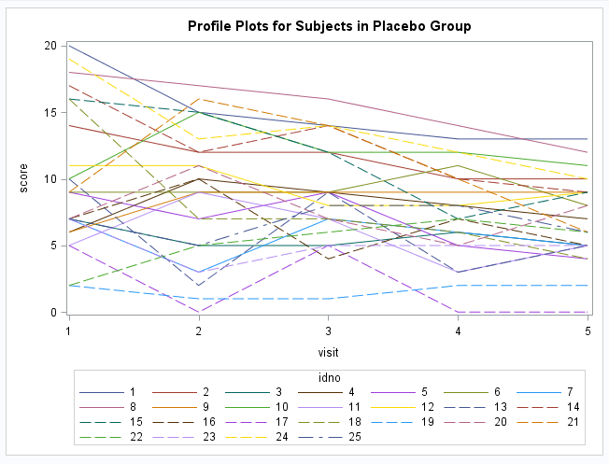

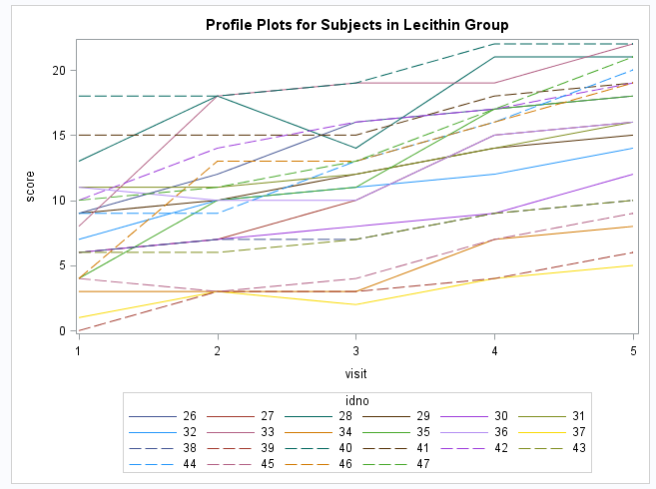

1. The model is given below.
$$y_{ijk}=β_{0}+b_{0k}+β_{1}{visit}_{j}+β_{2}{group}_{i}+e_{ij}$$

$$b_{0k}\sim iid N(0, σ_{b}^{2})$$

$$e_{ij}\sim iid N(0, σ^{2})$$

2. The implied covariance between repeated measures on a subject is 0.
3. The model in part b is fit using the maximum likelihood option.
   * 1. The estimates of the variance components are ${\hat{σ}}_{b}^{2}=$ 15.1284 and $σ^{2}=$ 8.2462.
     2. The fixed effects are both significant at a 5% level and the estimate of $β_{0}$ is -3.0556, which means there is evidence to suspect that the treatment has helped.
     3. The predicted profiles suggest that the model is not a great fit. The profile plots using the data showed an overall downward trend for the placebo and upward trend for the lecithin. However, both predicted plots show upward trends in scores over time even though the intercepts of the placebo plots are higher on average than the lecithin plots.
4. The model is given below.
$$y_{ijk}=β_{0}+b_{0k}+β_{1}{visit}_{j}+b_{1k}{visit}_{j}+β_{2}{group}_{i}+e_{ij}$$

$$b_{0k}\sim iid N(0, σ_{b0}^{2})$$

$$b_{1k}\sim not specified in part e$$

$$e_{ij}\sim iid N(0, σ^{2})$$

5. The model in part e is fit using maximum likelihood and an unstructured covariance.
   * 1. 38.7228, $var\left(b_{1k}\right)=$ 2.0570, $cov\left(b_{1k},b_{2k}\right)=$-6.8253, $var\left(e_{ij}\right)=$ 3.1036. To test if the covariance component estimates are significant, we compare the log likelihood of the reduced model, where $cov\left(b_{1k},b_{2k}\right)=0$ versus the full model of above. The -2 times the log likelihood for the reduced model is 1196.9 and the full model is 1183.4. The likelihood ratio test gives a test statistic of 13.5, which is distributed as chi square with 1 degree of freedom and has a p-value of .0002. Therefore, the covariance component estimates are significant. The correlation between the slopes and intercepts is -.764753.
     2. All the fixed effects are significant at the 1% level which gives evidence to support that the scores change depending on the visit, and the treatments produce different results. .
     3. The model for part f is a better model than the random intercept model. This follows from the likelihood ratio test between the two models. The -2 log likelihood for the random intercept and visit variable model is 1196.9. The -2 log likelihood for the random intercept only random variable is 1271.7.The likelihood ratio test produces a test statistic of 74.8 which is chi squared with a 1 degree of freedom and a p-value close to zero.
     4. The plot of predicted profiles for the random intercept and visit variable model match the data much better than the random intercept model. The predicted profiles show an increasing trend for the lecithin treatment and a decreasing trend for the placebo treatment, which matches the data. For the random intercept model, the trend for the placebo treatment was increasing, which did not match the data.
6. The random intercept and visit variable is fit using maximum likelihood and using an unstructured covariance for random effects but allowing for AR(1) structure in the errors. The AIC for this new model is 1199.2. The AIC for the identical model but without AR(1) , part f, is 1197.4. Therefore, the most appropriate model is the model in part f that has unstructured covariance but no AR(1) structure.